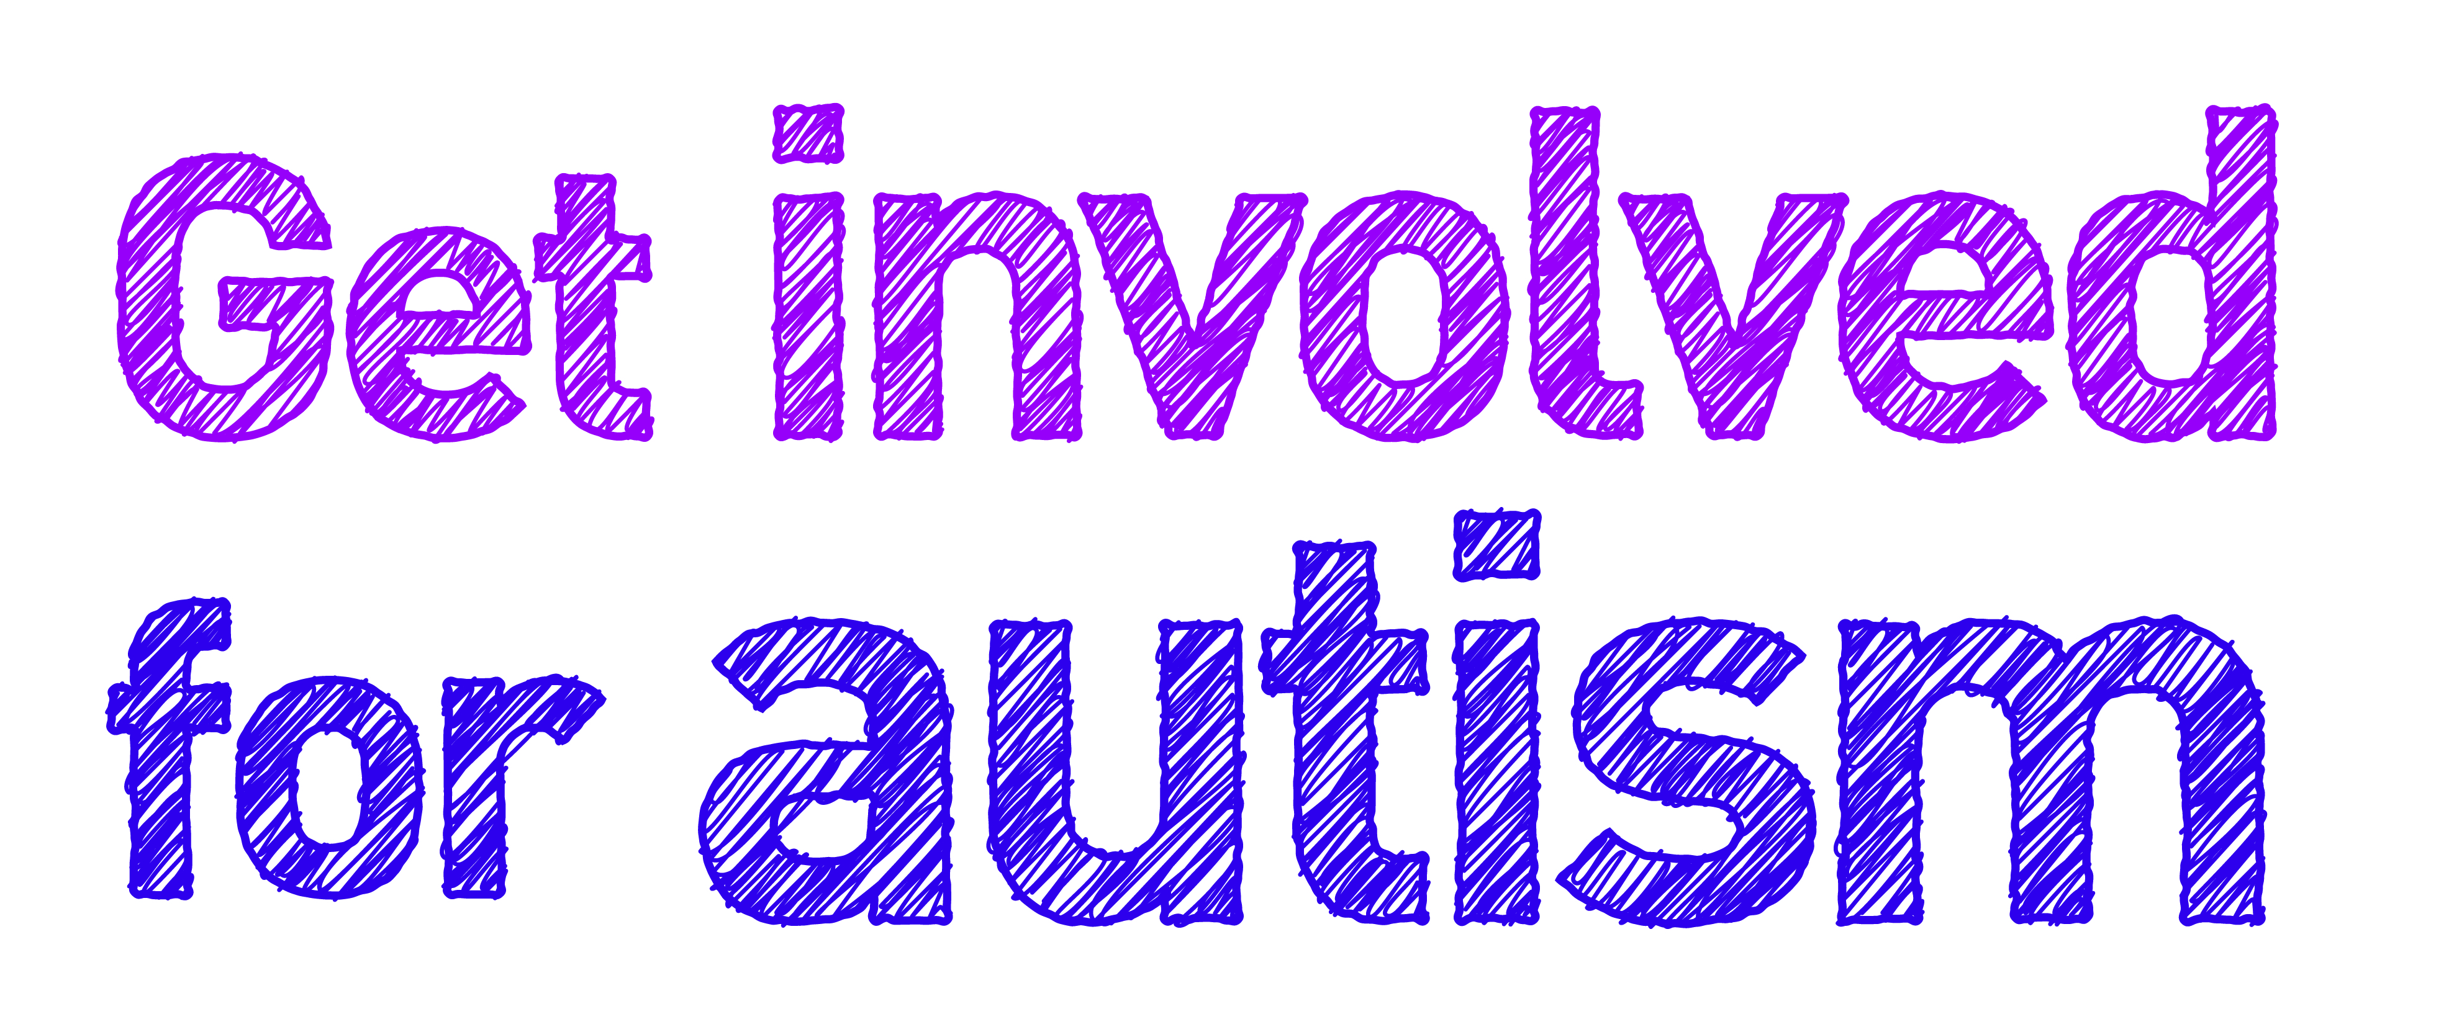

Enabling people living with autism in Scotland through the whole life journey

scottishautism.org

Enabling people living with autism in Scotland through the whole life journey